Module 4 Assignment – Creating a NoSQL Database in MongoDB Atlas

Sasanka Vepakomma

Ira A. Fulton Schools of Engineering, Arizona State University

IFT 598: Middleware Programming & Database Security

Prof. Dinesh Sthapit

Due: Oct 23, 2022

**Screenshots**

App running on Port 3000

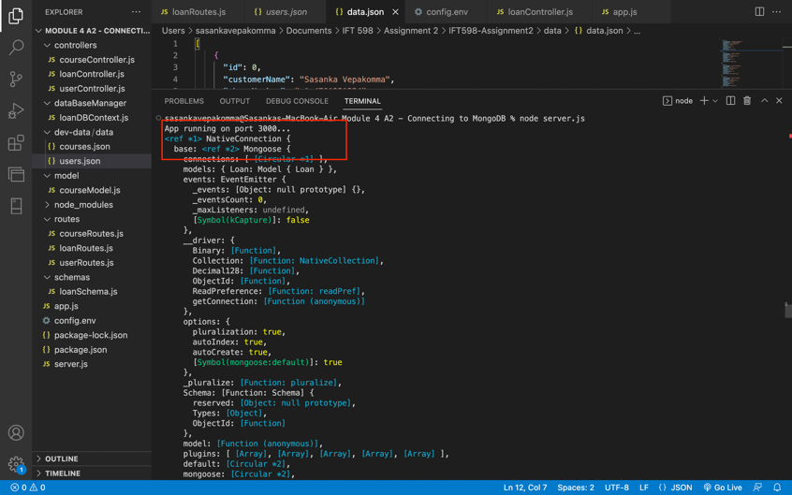

Successful DB Connection

Delete Request

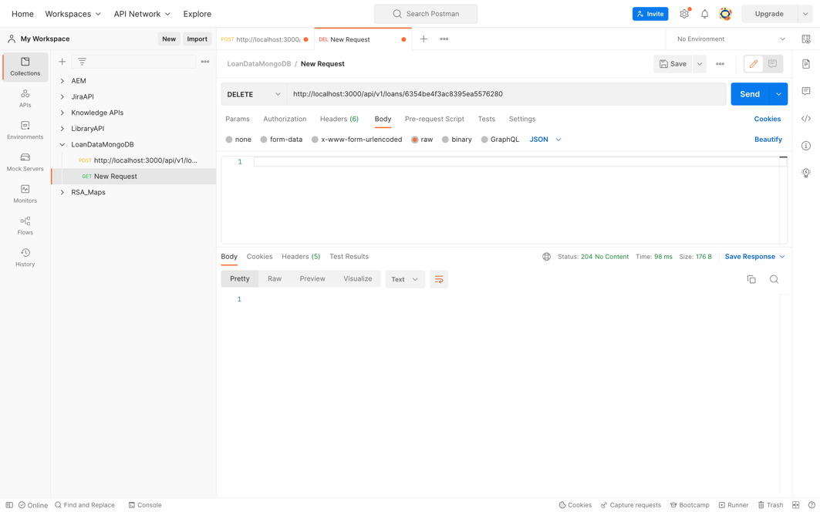

Get All loans

Get by ID

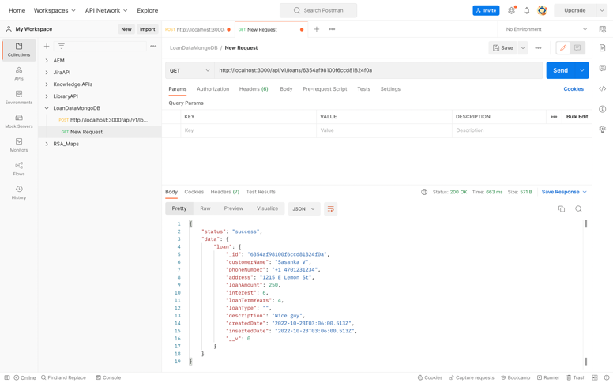

Post new Loan

Modify a loan record by ID using PUT request

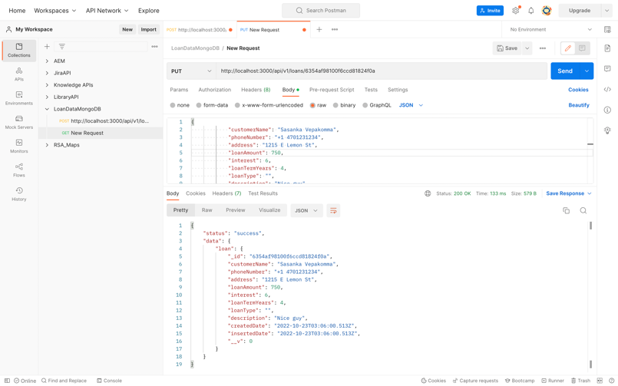

List of Postman Requests

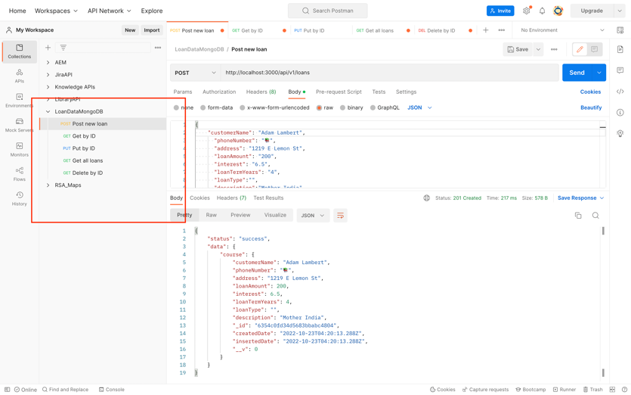

Mongoose Schema

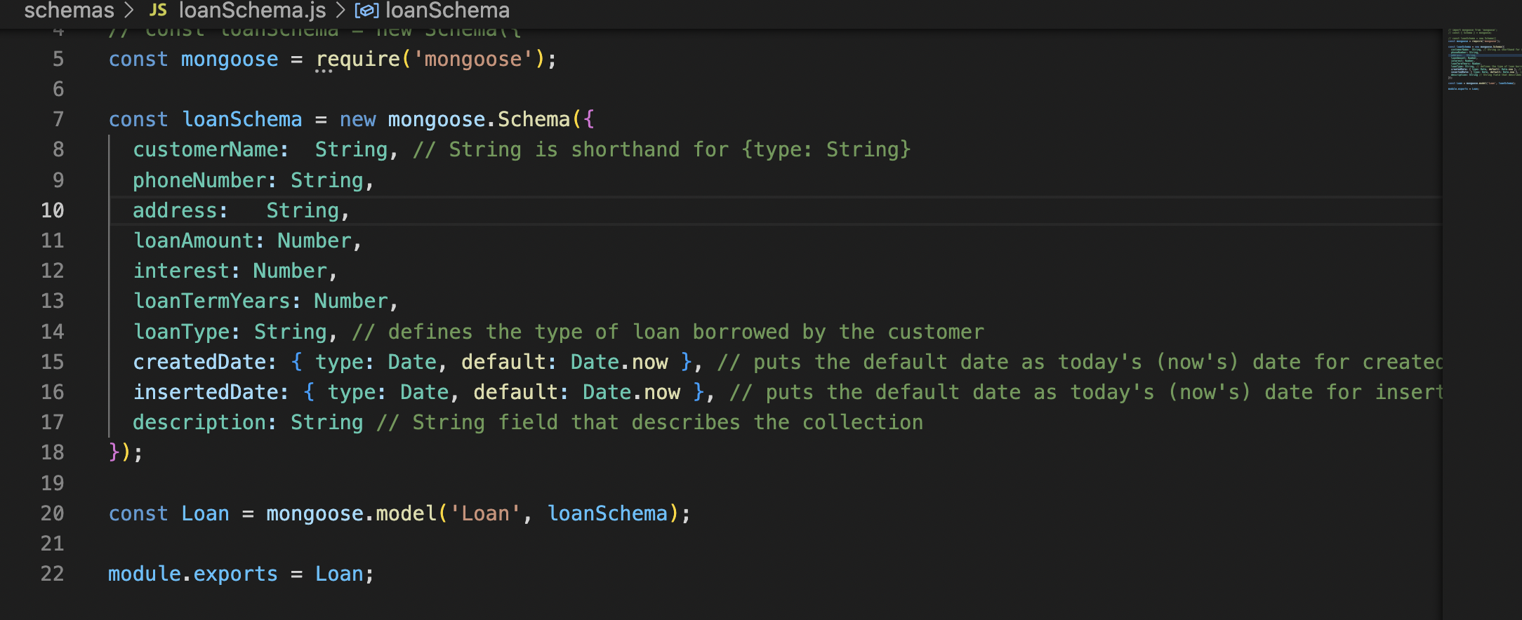

**GitHub Link**

<https://github.com/vsasanka/IFT598MiddlewareProg-DBSecurity/tree/main/Module%204%20A2%20-%20Connecting%20to%20MongoDB>

**Postman Test collection**

{

"info": {

"_postman_id": "f8d62710-58e1-49ba-84a0-dd18bd0c669d",

"name": "LoanDataMongoDB",

"schema": "https://schema.getpostman.com/json/collection/v2.1.0/collection.json",

"_exporter_id": "10231732"

},

"item": [

{

"name": "Post new loan",

"request": {

"auth": {

"type": "noauth"

},

"method": "POST",

"header": [],

"body": {

"mode": "raw",

"raw": "{\n \"customerName\": \"Kyle Jenner\",\n \"phoneNumber\": \"📚\",\n \"address\": \"1219 E Lemon St\",\n \"loanAmount\": \"200\",\n \"interest\": \"6.5\",\n \"loanTermYears\": \"4\",\n \"loanType\":\"\",\n \"description\":\"Mother India\"\n}",

"options": {

"raw": {

"language": "json"

}

}

},

"url": {

"raw": "http://localhost:3000/api/v1/courses",

"protocol": "http",

"host": [

"localhost"

],

"port": "3000",

"path": [

"api",

"v1",

"courses"

]

}

},

"response": []

},

{

"name": "Get by ID",

"request": {

"method": "GET",

"header": []

},

"response": []

},

{

"name": "Put by ID",

"request": {

"method": "PUT",

"header": [],

"body": {

"mode": "raw",

"raw": "{\n \"customerName\": \"Sasanka Vepakomma\",\n \"phoneNumber\": \"+1 4701231234\",\n \"address\": \"1215 E Lemon St\",\n \"loanAmount\": \"800\",\n \"interest\": \"6\",\n \"loanTermYears\": \"4\",\n \"loanType\":\"\",\n \"description\":\"Nice guy\"\n}",

"options": {

"raw": {

"language": "json"

}

}

},

"url": {

"raw": "http://localhost:3000/api/v1/loans/6354af98100f6ccd81824f0a",

"protocol": "http",

"host": [

"localhost"

],

"port": "3000",

"path": [

"api",

"v1",

"loans",

"6354af98100f6ccd81824f0a"

]

}

},

"response": []

},

{

"name": "Get all loans",

"request": {

"method": "GET",

"header": []

},

"response": []

},

{

"name": "Delete by ID",

"request": {

"method": "GET",

"header": []

},

"response": []

}

]

}